**Assessment of Air Quality in Different cities**

*SUBMITTED BY*

**Rishabh Singhal (2018btechcse013)**

**Aishwaryaditya Jha (2018btechcse123)**

**Naveen Pratap Singh (2018btechcse009)**

**Sanyukta Tanwar(2018btechcse117)**

**Akshat Awasthi(2018btechcse104)**

**as Project – II**

***of***

**Computational Data Analysis**

**And**

**Environmental studies**



**Institute of Engineering and Technology**

**JK Lakshmipat University Jaipur**

April 2019

**Table Of Content**

Contents Page

Abstract… 1

Introduction ……………………………………………………………………………… 2

Review of Literature 4

Objective 5

|  |
| --- |
| Methodology.……………………….…………….……………………………………… 6 |
| Analysis……………………………………………………………………………………8  Result & Discussion ……………………………………………………………………..25 |
| Conclusion………………………………………………………………………………..37 |
| Reference …………………………………………………………………………………38 |

* Abstract
* Air pollution is one of the major environmental issues. It can cause adverse health effects such as cancer, cardiovascular diseases and high mortality rates. High population density is a huge contributory factor of air pollution in cities and urbanized areas.
* Rapid economic growth has brought many benefits to India; the environment has suffered, exposing the population serious air pollution [1]. The consequences of pollution have led to poor urban air quality in many Indian cities. The air pollution and the resultant air quality can be attributed to emissions from transportation, industrial and domestic activities. The air quality has been, therefore, an issue of social concern in the backdrop of various developmental activities. Though the measurement of air quality is complicated, there are a few pollutants which regulators keep a watchful eye on through regular monitoring. The most watched pollutants include particular matter (PM), nitrogen dioxide (NO2), sulphur dioxide (SO2) and carbon dioxide (CO2)[2]. Due to pollution, the ambient air quality in major cities in India is now very poor. The annual average concentration of suspended particulate matter (PM10) is very high in Indian cities. In particular, many cities have exceeded the officially designated critical levels, not to mention the ambient air quality standards set by the World Health Organization (WHO). There is an urgent need to adopt various strategies in planning air quality, total air quality control to improve urban air quality. Epidemiological studies should be taken up to show how ambient air pollution is affecting peopleâŸs health and quantify this information in order to provide policy tools for air quality planning. Exposure to air pollutants is largely beyond the control of individuals and requires action by public authorities at the national, regional and even international levels. The norms for ambient air quality have been revisited and various industry specific emissions standards are to be revisited and notified from time to time**.**
* **Introduction:**

AIR POLLUTION & CONTROL

Air Pollution - causes, effects and control measures

INTRODUCTION

Air pollution is the introduction of particulates, biological molecules, or other harmful materials into Earth's atmosphere, causing diseases, death to humans, damage to other living organisms such as animals and food crops, or the natural or built environment.

According to **The Air (Prevention and Control of Pollution) Act, 1981**, “Air pollution is the presence of any solid, liquid, or gaseous substances in the atmosphere in such concentration as may be or tend to be injurious to human beings or other living creatures or plants or property or environment”.[1]

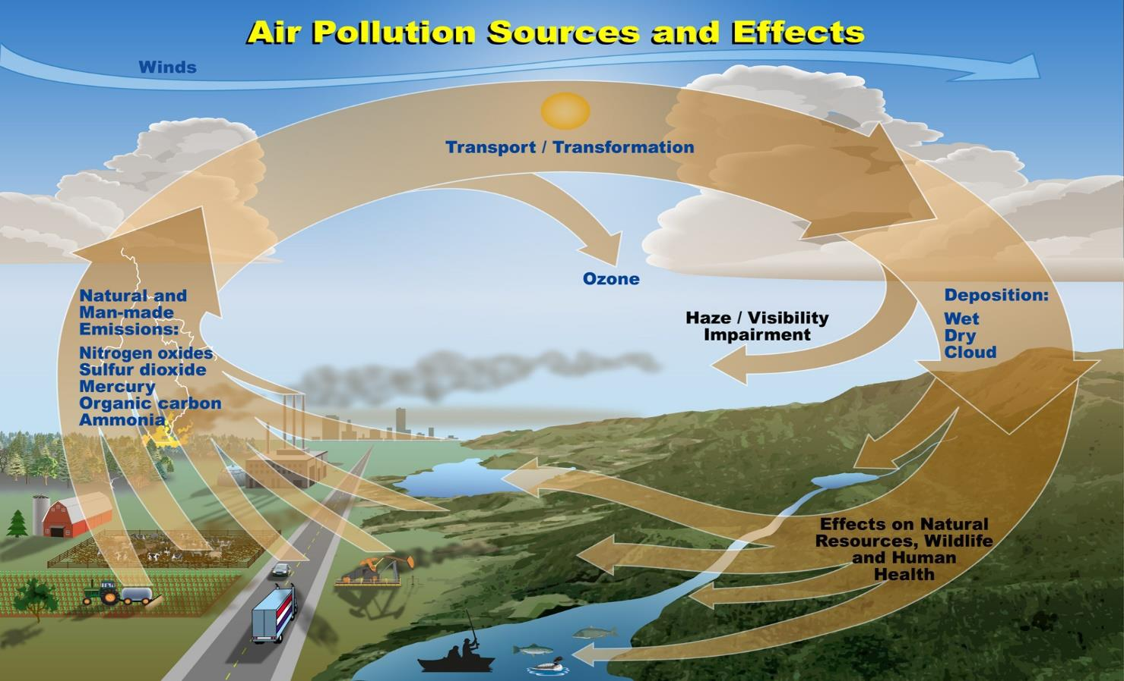

**Goal 13: Climate action**

There is no country that is not experiencing the drastic effects of climate change. Greenhouse gas emissions are more than 50 percent higher than in 1990. Global warming is causing long-lasting changes to our climate system, which threatens irreversible consequences if we do not act.

Supporting vulnerable regions will directly contribute not only to Goal 13 but also to the other SDGs. These actions must also go hand in hand with efforts to integrate disaster risk measures, sustainable natural resource management, and human security into national development strategies. It is still possible, with strong political will, increased investment, and using existing technology, to limit the increase in global mean temperature to two degrees Celsius above pre-industrial levels, aiming at 1.5°C, but this requires urgent and ambitious collective action.[3]

**Goal 15: Life on Land**

Human life depends on the earth as much as the ocean for our sustenance and livelihoods. Plant life provides 80 percent of our human diet, and we rely on agriculture as an important economic resource and means of development. Forests account for 30 percent of the earth’s surface, providing vital habitats for millions of species and important sources for clean air and water; as well as being crucial for combating climate change.

The SDGs aim to conserve and restore the use of terrestrial ecosystems such as forests, wetlands, drylands and mountains by 2020.[4]

Review of Literature :

Literature study was carried out to find out the literature related to the effect of air pollution in an urban areas are discussed below.

**Shinggu, D.Y. Patel*,* (2007)** suggested the elemental concentrations of heavymetal pollutants that may be present in street dust samples and told that these pollutants did not originate from commonanthropogenic sources because some heavy metals are soil derived automobile emission, welding of metal and exhaust from generators may be the major sources of the elements.[5]

**Senthilnathan.T, (2008)** observed that the pollutant values always exceed theNAAQS value throughout the sampling period by a very large amount as a result the statistical calculations made on pollutant data showed significant changes and found that best curve fit for cubic equations. [6]

**Aromar Revi (2008)**gave the importance for urban areas of an effective ruraladaptation agenda especially in maintaining the productivity and functioning of rural systems and highlighted the importance of infrastructure investments, taking into account climate changes, long lifespan of most infrastructure, urban management engaging with changing risk profiles are taken into account.

**Naresh Kumar and Andrew D.Foster (2009)**reported that air pollution levelsin Delhi and its surroundings were significantly higher than that of recommended World Health Organization and also the air quality regulations in the city and its surrounding areas are adversely affected due to major contribution of both fine and coarse particles from industries and trucks.[7]

**Gottinger Strasse (Hannover, Germany)** told that a dispersive velocity scale was evaluated using statistical methods for windward and leeward conditions in which leeward conditions a 'critical wind speed' is defined as the roof -level wind speed at which traffic and wind induced turbulences inside the street canyon are equal and it varied with traffic density between 2 m s−1 and 4.5 m s−1.[8]

**Mehta UK (2002)23** was found to be the impact zone for ambient air qualityaround SIEL chemical complex by selecting five ambient air-monitoring stations in this area and identified sulphur dioxide is the significant pollutant within the study region.

**Singh Gurdeep, Puri SK (2004)29** observed the overall ambient status in thecoalfield was found not satisfactory and in the indoor microenvironment, RSP concentrations were found higher than expected. Geological rocks in the coalfield, coal burning, wear and tear of tyres and metallic parts of HEMM and other machines operating in the coalfield were found to contribute to air pollution and suggested the strategy for Air Quality Management.[9]

**Tripathy AK, Panigrahi GP (2001)41** evaluated the air quality index level ofatmospheric pollution where the parameter has been computed for judging the ambient air quality around OSCOM (IRE Ltd) and resulted that the atmosphere towards the eastern side of OSCOM shows only moderate air pollution due to suspended particulate matter.

Objective :

The objective of the paper is to analyse the problem of air pollution in different tier cities of India and its impact on the society which is major problem faced by the people of India nowadays. We will also work on the causes and the problems which are faced by the people living in these cities.

**Objective1**-To compare the air quality in different years for Tier–1 cities .



**Objective2**-To compare the air quality in different years for Tier–2 cities.



**Objective3**-To compare the air quality in different years for Tier - 3 cities.

**Objective4**-To compare the air quality in different years for Rural Areas.



**Objective5**-To find out the ranks of all cities on the basis of pollution related to Pm10 concentration.

Methodology :

Hypothesis testing is a statistical method that is used in making statistical decisions using experimental data. Hypothesis Testing is basically an assumption that we make about the population parameter.

Hypothesis testing is an essential procedure in statistics. A hypothesis test evaluates two mutually exclusive statements about a population to determine which statement is best supported by the sample data. When we say that a finding is statistically significant, it’s thanks to a hypothesis test**.**



**One-way ANOVA**

**What is this test for?**

The one-way analysis of variance (ANOVA) is used to determine whether there are any statistically significant differences between the means of three or more independent (unrelated) groups. This guide will provide a brief introduction to the one-way ANOVA, including the assumptions of the test and when you should use this test.

**What does this test do?**

The one-way ANOVA compares the means between the groups you are interested in and determines whether any of those means are statistically significantly different from each other. Specifically, it tests the null hypothesis:



where *µ* = group mean and *k* = number of groups. If, however, the one-way ANOVA returns a statistically significant result, we accept the alternative hypothesis (HA), which is that there are at least two group means that are statistically significantly different from each other.

At this point, it is important to realize that the one-way ANOVA is an **omnibus** test statistic and cannot tell you which specific groups were statistically significantly different from each other, only that at least two groups were.

2. Power Method

The power method is a simple iteration method that can be used to find λ and for a given matrix A, where λ is the largest eigenvalue and is the corresponding eigenvector.

Similarly, the inverse power method is used to find the smallest eigenvalue and its corresponding vector, which is very similar to power method.

We first assume that the matrix A has a dominant eigenvalue with the corresponding dominant eigenvectors. As stated before, the power method for approximating eigenvalues is iterative. Hence, we start with an initial approximation of the dominant eigenvector of A, which must be non-zero. Thus, we obtain a sequence of eigenvectors given by

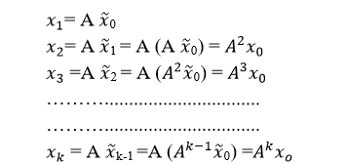

When k is large, we can obtain a good approximation of the dominant eigenvector of A by properly scaling the sequence. [10]

**ANALYSIS**

**1.Data of tier 1 cities**

|  |  |  |  |  |  |  |  |
| --- | --- | --- | --- | --- | --- | --- | --- |
| Year | 2011 | 2012 | 2013 | 2014 | 2015 | 2016 | 2017 |
| cities | PM10 | PM10 | PM10 | PM10 | PM10 | PM10 | PM10 |
| Bangalore | 91 | 121 | 113 | 139 | 119 | 103 | 92 |
| Chennai | 92 | 57 | 75 | 57 | 59 | 65 | 62 |
| Delhi | 222 | 237 | 221 | 217 | 220 | 278 | 241 |
| Hyderabad | 74 | 79 | 90 | 95 | 93 | 100 | 108 |
| Kolkata | 113 | 135 | 159 | 122 | 105 | 113 | 120 |
| Mumbai | 116 | 117 | 117 | 96 | 107 | 119 | 151 |
| Pune | 113 | 93 | 88 | 92 | 99 | 107 | 102 |

|  |  |  |
| --- | --- | --- |
| cities | PM10 | Population(in lakhs) |
| Bangalore | 92 | 84.3 |
| Chennai | 62 | 46.5 |
| Delhi | 241 | 190 |
| Hyderabad | 108 | 68.1 |
| Kolkata | 120 | 45 |
| Mumbai | 151 | 184 |
| Pune | 102 | 67.5 |

**Claim 1***-*PM10 concentration in tier1 cities have not changed from 2011 to 2017.

**Building of hypothesis-**

Null Hypothesis H0: Population means are all equal i.e., µ1 = µ2 = … = µ7(αi = 0, for all i)

Alternative Hypothesis: All population means are not equal i.e., µ1 ≠ µ2 ≠ … ≠ µ7

(αi = 0, for at least i)

Level of Significance: 0.01.Where ,

µ1 is the mean of the total PM10 concentration in 2011.

µ2 is the mean of the total PM10 concentration in 2012.

µ3 is the mean of the total PM10 concentration in 2013.

µ4 is the mean of the total PM10 concentration in 2014.

µ5 is the mean of the total PM10 concentration in 2015

µ6 is the mean of the total PM10 concentration in 2016.

µ7 is the mean of the total PM10 concentration in 2017.

**C**r**iteria of rejection –**

Reject the null hypothesis if F>2.131

**Calculations  -**

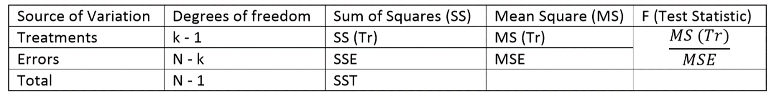

|  |  |  |  |  |
| --- | --- | --- | --- | --- |
| *Source of Variation* | *df* | *SS* | *MS* | *F* |
| Treatment | 6 | 865.3878 | 144.2313 | 0.046762 |
| Within Groups | 42 | 129542.9 | 3084.354 |  |
| Total | 48 | 130408.2 |  |  |

**Decision:**

f= 0.046

0.046>2.131;Null Hypothesis cannot be rejected, which signifies that the PM10 concentration have changed tier 1 cities in India from 2011 to 2017.

**2.Data for tier2:**

|  |  |  |  |  |  |  |  |
| --- | --- | --- | --- | --- | --- | --- | --- |
| year | 2011 | 2012 | 2013 | 2014 | 2015 | 2016 | 2017 |
| cities | PM10 | PM10 | PM10 | PM10 | PM10 | PM10 | PM10 |
| Agra | 155 | 196 | 184 | 178 | 186 | 198 | 184 |
| Ahmedabad | 83 | 83 | 79 | 84 | 89 | 108 | 120 |
| Allahabad | 258 | 317 | 235 | 250 | 250 | 196 | 140 |
| Amritsar | 210 | 202 | 180 | 145 | 148 | 194 | 154 |
| Asansol | 145 | 80 | 84 | 85 | 83 | 92 | 83 |
| Bhopal | 170 | 173 | 220 | 160 | 158 | 89 | 93 |
| Coimbatore | 102 | 68 | 56 | 49 | 47 | 59 | 49 |
| Dhanbad | 207 | 178 | 151 | 166 | 168 | 226 | 238 |
| Faridabad | 174 | 184 | 196 | 199 | 195 | 204 | 216 |
| Indore | 132 | 143 | 156 | 143 | 97 | 95 | 80 |
| Jabalpur | 73 | 75 | 69 | 73 | 90 | 71 | 74 |
| Jaipur | 139 | 187 | 160 | 150 | 171 | 199 | 177 |
| Jodhpur | 168 | 189 | 176 | 190 | 152 | 168 | 180 |
| Kanpur | 183 | 215 | 201 | 199 | 201 | 217 | 224 |
| Kota | 139 | 156 | 122 | 127 | 134 | 109 | 130 |
| Lucknow | 189 | 211 | 192 | 174 | 169 | 214 | 246 |
| Ludhiana | 221 | 228 | 204 | 146 | 139 | 139 | 162 |
| Madurai | 44 | 48 | 41 | 46 | 64 | 76 | 67 |
| Meerut | 12 | 129 | 134 | 154 | 154 | 157 | 153 |
| Nagpur | 108 | 103 | 89 | 103 | 90 | 118 | 102 |
| Nashik | 96 | 95 | 85 | 72 | 78 | 85 | 81 |
| Patna | 158 | 166 | 178 | 184 | 176 | 212 | 156 |
| Pimpri Chinchwad | 92 | 89 | 86 | 93 | 102 | 105 | 82 |
| Pune | 113 | 93 | 88 | 92 | 99 | 107 | 102 |
| Raipur | 268 | 291 | 305 | 329 | 188 | 148 | 103 |
| Rajkot | 98 | 99 | 87 | 82 | 83 | 92 | 106 |
| Ranchi | 170 | 202 | 177 | 197 | 220 | 196 | 142 |
| Surat | 106 | 97 | 88 | 89 | 89 | 92 | 106 |
| Thane | 72 | 92 | 110 | 114 | 117 | 122 | 125 |
| Vadodara | 92 | 102 | 89 | 87 | 87 | 92 | 108 |
| Varanasi | 127 | 138 | 145 | 139 | 145 | 256 | 244 |
| Vijayawada | 90 | 65 | 104 | 100 | 110 | 102 | 99 |
| Visakhapatnam | 80 | 97 | 67 | 64 | 61 | 77 | 73 |

|  |  |  |  |  |  |  |  |  |  |  |  |  |  |  |  |  |  |  |  |  |  |  |  |  |  |  |  |  |  |  |  |  |  |  |  |  |  |  |  |  |  |  |  |  |
| --- | --- | --- | --- | --- | --- | --- | --- | --- | --- | --- | --- | --- | --- | --- | --- | --- | --- | --- | --- | --- | --- | --- | --- | --- | --- | --- | --- | --- | --- | --- | --- | --- | --- | --- | --- | --- | --- | --- | --- | --- | --- | --- | --- | --- |
| |  |  |  |  | | --- | --- | --- | --- | | cities | PM10 | population(in lakhs) | Vehicles(in lakhs) | | Lucknow | 246 | 28.2 | 17 | | Kanpur | 244 | 29.2 | 14.62 | | Agra | 238 | 18.9 | 9.05 | | Jaipur | 224 | 30.7 | 22.5 | | Jodhpur | 184 | 10.5 | 9.16 | | Ludhiana | 180 | 16.2 | 12.36 | | Patna | 177 | 20.5 | 10.19 | | Amritsar | 162 | 11.3 | 8.03 | | Varanasi | 156 | 12 | 7.69 | | Dhanbad | 154 | 11.6 | 5.63 | |

**2.Claim 2***-*PM10 concentration in tier2 cities have changed from 2011 to 2017.

**Building of hypothesis-**

Null Hypothesis H0: Population means are all equal i.e., µ1 = µ2 = … = µ7(αi = 0, for all i)

Alternative Hypothesis: All population means are not equal i.e., µ1 ≠ µ2 ≠ … ≠ µ7

(αi = 0, for at least i)

Level of Significance: 0.05.Where ,

µ1 is the mean of the total PM10 concentration in 2011.

µ2 is the mean of the total PM10 concentration in 2012.

µ3 is the mean of the total PM10 concentration in 2013.

µ4 is the mean of the total PM10 concentration in 2014.

µ5 is the mean of the total PM10 concentration in 2015

µ6 is the mean of the total PM10 concentration in 2016.

µ7 is the mean of the total PM10 concentration in 2017.

**C**r**iteria of rejection –**

Reject the null hypothesis if F>2.13

**Calculations  -**



Here ,

|  |  |  |  |  |
| --- | --- | --- | --- | --- |
| *Source of Variation* | *df* | *SS* | *MS* | *F* |
| Treatment | 6 | 6636.978856 | 1106.163 | 0.19745 |
| Within Groups | 218 | 752247.8034 | 3450.678 |  |
| Total | 224 | 758884.7822 |  |  |

**Decision:**

f= 2.13

0.197>2.13;Null Hypothesis cannot be rejected, which signifies that the PM10 concentration have not changed in tier 2 cities in India from 2011 to 2017.

**3.Data for tier 3 cities: -**

|  |  |  |  |  |  |
| --- | --- | --- | --- | --- | --- |
| cities | pm10(2011) | pm10(2012) | pm10(2013) | pm10(2014) | pm10(2015) |
| Warangal | 61 | 49 | 184 | 178 | 186 |
| Nagaon | 86 | 79 | 132 | 100 | 169 |
| Hoshiarpur | |  | 164 | 144 | 151 |
| Khanna | 237 | 213 | 204 | 146 | 139 |
| Latur | 116 | 117 | 131 | 112 | 139 |
| Faridkot |  |  | 165 | 135 | 145 |
| Nagda | 101 | 103 |  | 163 | 125 |
| Howrah | 131 | 186 | 187 | 111 | 127 |
| Ulhasnagar | 114 | 111 | 122 | 136 | 122 |
| Kolasib | 94 | 57 | 101 | 129 | 122 |
| west Singhbhum | 231 | 153 | 113 | 139 | 119 |
| Tinsukia | 56 | 57 | 99 | 57 | 119 |
| Dharamshala | |  | 142 | 138 | 118 |
| Nalagarh | 89 | 89 | 117 | 128 | 117 |
| Margherita | 53 | 54 | 77 | 55 | 115 |
| Raniganj | 153 | 126 | 163 | 134 | 114 |
| Barrackpore | 98 | 130 | 166 | 103 | 113 |
| Sindri | 214 | 170 |  |  | 111 |
| Vishakhapatnam | 80 | 65 | 104 | 100 | 110 |
| Chandrapur | 152 | 148 | 91 | 141 | 104 |
| Badlapur | 105 | 124 | 129 | 129 | 103 |
| Durgapur | 166 | 108 | 160 | 102 | 101 |
| Cuttack | 70 | 68 | 83 | 94 | 100 |
| Dewas | 84 | 92 | 156 | 143 | 97 |
| Guwahati | 93 | 92 | 147 | 88 | 97 |
| Lunglei | 41 | 41 | 85 | 91 | 93 |
| Mangalore | 55 | 31 | 79 | 112 | 92 |
| Dera Bassi | 105 | 129 |  | 74 | 90 |
| Tezpur | 60 | 11 | 120 | 71 | 90 |
| Wayanad | 28 | 33 | 102 | 93 | 90 |
| Vasco | 57 | 84 | 79 | 84 | 89 |
| Haldia | 136 | 238 | 146 | 136 | 87 |
| Anklesvar | 91 | 99 | 90 | 85 | 84 |
| Akola | 137 | 139 | 84 | 85 | 83 |
| Shimla | 54 | 57 | 74 | 87 | 83 |
| Balasore | 76 | 82 | 87 | 90 | 81 |
| Berhampur | 75 | 80 | 83 | 92 | 81 |
| Sunder Nagar | 85 | 94 | 93 | 77 | 80 |
| Rourkela | 104 | 98 | 51 | 55 | 77 |
| Saraikela | 216 | 160 | 121 | 100 | 75 |
| Hubli-Dharwad | 73 | 77 | 47 | 67 | 75 |
| Margao | 90 | 67 | 60 | 70 | 74 |
| Tirupati | 37 | 37 | 76 | 69 | 73 |
| Gobindgarh | 166 | 201 |  | 55 | 72 |
| Silchar | 78 | 91 | 135 | 80 | 72 |
| Prakasam |  |  | 118 | 96 | 70 |
| Patencheru | 76 | 108 | 84 | 55 | 67 |
| Korba | 94 | 81 | 77 | 72 | 66 |
| Ujjain | 98 | 80 |  |  | 64 |
| Paonta Sahib | 72 | 153 | 68 | 66 | 61 |
| Honda | 184 | 135 | 54 | 65 | 60 |
| Ramagundam | 65 | 82 | 49 | 52 | 58 |
| Parwanoo | 87 | 79 | 47 | 48 | 55 |
| Palakkad | 23 | 37 | 54 | 51 | 55 |
| Angul | 106 | 106 | 75 | 72 | 54 |
| Marmagao | 72 | 112 | 46 | 51 | 52 |
| Tilamol | 150 | 114 | 50 | 54 | 51 |
| Panaji | 87 | 67 | 50 | 54 | 51 |
| Usgao | 125 | 121 | 49 | 52 | 50 |
| Bicholim | 111 | 119 | 48 | 52 | 49 |
| Curchorem | 87 | 112 | 54 | 46 | 49 |
| Mandya | 43 | 49 | 60 | 56 | 48 |
| Pathanamthitta | 22 | 23 | 46 | 55 | 48 |
| Kala Amb | 170 | 165 | 48 | 40 | 46 |
| Alappuzha | 41 | 50 | 36 | 35 | 46 |
| Damtal | 67 | 97 |  | 32 | 37 |
| Thiruvananthapuram | 58 | 55 | 42 | 36 | 37 |
| Byrnihat | 178 | 138 | 36 | 42 | 36 |
| Talcher | 109 | 116 | 43 | 42 | 35 |
| Puducherry | 42 | 42 |  | 35 | 35 |
| Dawki | 63 | 44 | 24 | 28 | 26 |
| Tuticorin | 130 | 134 | 61 | 67 |  |
| Bhubneshwar | 121 | 81 |  | 112 |  |
| Amravati | 100 | 100 |  |  |  |
| Shillong | 72 | 65 |  |  |  |
| Thane | 56 | 72 |  |  |  |
| Lote | 86 | 40 |  |  |  |

**Population and PM 10 Concentration for top 10 polluted tier 3 cities**

|  |  |  |
| --- | --- | --- |
| cities | pm10(2015) | population(in Lakhs) |
| Warangal | 186 | 8.12 |
| Nagaon | 169 | 18.19 |
| Hoshiarpur | 151 | 16.8 |
| Khanna | 139 | 1.28 |
| Latur | 139 | 7.83 |
| Faridkot | 145 | 6.87 |
| Nagda | 125 | 1 |
| Howrah | 127 | 5.8 |
| Ulhasnagar | 122 | 5.06 |
| Kolasib | 122 | 0.83 |

**Claim 3***-*PM10 concentration in tier3 cities have increased from 2011 to 2015.

**Building of hypothesis-**

Null Hypothesis H0: Population means are all equal i.e., µ1 = µ2 = … = µ5(αi = 0, for all i)

Alternative Hypothesis: All population means are not equal i.e., µ1 ≠ µ2 ≠ … ≠ µ5 (αi = 0, for at least i)

**Level of Significance: 0.05**. Where,

µ1 is the mean of the total PM10 concentration in 2011. µ2 is the mean of the total PM10 concentration in 2012. µ3 is the mean of the total PM10 concentration in 2013. µ4 is the mean of the total PM10 concentration in 2014. µ5 is the mean of the total PM10 concentration in 2015.

**C**r**iteria of rejection –**

Reject the null hypothesis if F>2.39

**Calculations -**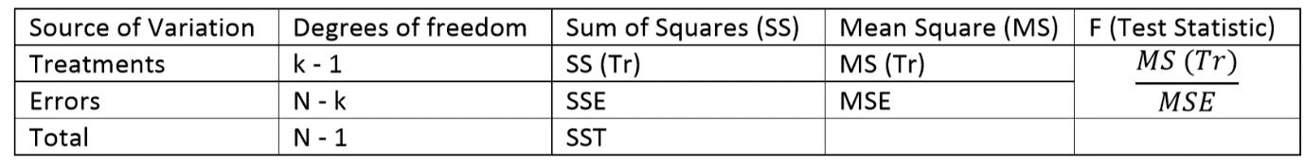

Here,

|  |  |  |  |  |  |  |
| --- | --- | --- | --- | --- | --- | --- |
| *Source of Variation* | *SS* | *df* | *MS* | *F* | *P-value* | *F crit* |
| Between Groups | 10943.23 | 4 | 2735.808 | 1.534755 | 0.191592 | 2.397604 |
| Within Groups | 620334.2 | 348 | 1782.569 |  |  |  |
|  |  |  |  |  |  |  |
| Total | 631277.4 | 352 |  |  |  |  |

F= 1.53

1.53>2.39; Null Hypothesis cannot be rejected, which signifies that the PM10 concentration have not increased in tier 3 cities in India from 2011 to 2015.

4.**Data for rural area:-**

|  |  |  |  |  |  |
| --- | --- | --- | --- | --- | --- |
| cities | 2011 | 2012 | 2013 | 2014 | 2015 |
| Jharia | 223 | 212 | 177 | 197 | 220 |
| Saraikela Kharsawan | 216 | 160 | 121 | 100 | 75 |
| Alwar | 214 | 151 | 160 | 150 | 171 |
| Muradabad | 145 | 165 | 160 | 201 | 168 |
| Raebareli | 133 | 163 | 177 | 160 | 157 |
| Unnao | 132 | 98 | 114 | 73 | 119 |
| Jalgaon | 118 | 130 | 122 | 137 | 118 |
| Jalna | 116 | 109 | 118 | 100 | 97 |
| Sibsagar | 99 | 109 | 120 | 90 | 70 |
| Patiala | 97 | 62 | 0 | 88 | 100 |
| Nalbari | 95 | 82 | 140 | 76 | 120 |
| Dimapur | 88 | 90 | 106 | 116 | 102 |
| Kolhapur | 86 | 110 | 97 | 90 | 78 |
| Kurnool | 82 | 74 | 59 | 56 | 62 |
| Amona | 79 | 90 | 54 | 52 | 52 |
| Assanora | 78 | 84 | 57 | 50 | 54 |
| solapur | 78 | 83 | 110 | 109 | 117 |
| Sagar | 77 | 120 | 0 | 0 | 90 |
| Kohima | 77 | 82 | 87 | 87 | 82 |
| Codli | 76 | 121 | 0 | 60 | 56 |
| Naya Nangal | 76 | 89 | 76 | 68 | 77 |
| Nalgonda | 75 | 79 | 56 | 62 | 0 |
| Devanagere | 67 | 75 | 26 | 25 | 25 |
| Champhai | 65 | 62 | 46 | 48 | 42 |
| Salem | 65 | 60 | 87 | 84 | 85 |
| Lakhimpur | 64 | 45 | 121 | 66 | 78 |
| Nellore | 63 | 62 | 76 | 77 | 82 |
| Golaghat | 63 | 55 | 101 | 63 | 124 |
| Gulburga | 63 | 65 | 96 | 90 | 75 |
| tura | 59 | 52 | 48 | 43 | 44 |
| Rayagada | 58 | 54 | 96 | 83 | 100 |
| daranga | 56 | 56 | 98 | 70 | 69 |
| Sambalpur | 52 | 53 | 110 | 124 | 135 |
| Mysore | 48 | 56 | 51 | 42 | 36 |
| Kottayam | 48 | 56 | 37 | 43 | 44 |
| Aizawl | 46 | 54 | 42 | 36 | 33 |
| Dibrugarh | 42 | 56 | 99 | 44 | 109 |
| Belgaum | 41 | 72 | 0 | 150 | 99 |
| Chitoor | 39 | 40 | 70 | 76 | 88 |
| Nanded | 39 | 53 | 85 | 72 | 78 |
| Pathanamthitta | 22 | 23 | 64 | 63 | 67 |

**Claim 4***-*PM10 concentration in rural area have increased from 2011 to 2015.

**Building of hypothesis-**

Null Hypothesis H0: Population means are all equal i.e., µ1 = µ2 = … = µ5(αi = 0, for all i)

Alternative Hypothesis: All population means are not equal i.e., µ1 ≠ µ2 ≠ … ≠ µ5 (αi = 0, for at least i)

**Level of Significance: 0.05**. Where,

µ1 is the mean of the total PM10 concentration in 2011. µ2 is the mean of the total PM10 concentration in 2012. µ3 is the mean of the total PM10 concentration in 2013. µ4 is the mean of the total PM10 concentration in 2014. µ5 is the mean of the total PM10 concentration in 2015.

**C**r**iteria of rejection –**

Reject the null hypothesis if F>2.41

**Calculations -**

Here,

|  |  |  |  |  |  |  |
| --- | --- | --- | --- | --- | --- | --- |
| Source of Variation | SS | df | MS | F | P-value | F crit |
| Between Groups | 17635.09 | 4 | 4408.772 | 0.649533 | 0.627843 | 2.417028 |
| Within Groups | 1350732 | 199 | 6787.599 |  |  |  |
| Total | 1368367 | 203 |  |  |  |  |

F= 0.002965984

0.002965984>2.39; Null Hypothesis cannot be rejected, which signifies that the PM10 concentration is constant in rural areas of India from 2011 to 2015.

**5.**Step 1: All tier cities data was collected and written together in the excel sheet. The data is given below:

|  |  |  |  |  |  |  |  |
| --- | --- | --- | --- | --- | --- | --- | --- |
|  | cities | 2011 | 2012 | 2013 | 2014 | 2015 |  |
| City | pm10 | pm10 | pm10 | pm10 | pm10 | sum |
| 1 | Lakhimpur | 64 | 45 | 121 | 66 | 78 | 374 |
| 2 | Nellore | 63 | 62 | 76 | 77 | 82 | 360 |
| 3 | Kurnool | 82 | 74 | 59 | 56 | 62 | 333 |
| 4 | Muradabad | 145 | 165 | 160 | 201 | 168 | 839 |
| 5 | Chitoor | 39 | 40 | 70 | 76 | 88 | 313 |
| 6 | daranga | 56 | 56 | 98 | 70 | 69 | 349 |
| 7 | Dibrugarh | 42 | 56 | 99 | 44 | 109 | 350 |
| 8 | Golaghat | 63 | 55 | 101 | 63 | 124 | 406 |
| 9 | Nalbari | 95 | 82 | 140 | 76 | 120 | 513 |
| 10 | Sibsagar | 99 | 109 | 120 | 90 | 70 | 488 |
| 11 | Amona | 79 | 90 | 54 | 52 | 52 | 327 |
| 12 | Assanora | 78 | 84 | 57 | 50 | 54 | 323 |
| 13 | Codli | 76 | 121 | 0 | 60 | 56 | 313 |
| 14 | Jharia | 223 | 212 | 177 | 197 | 220 | 1029 |
| 15 | Saraikela Kharsawan | 216 | 160 | 121 | 100 | 75 | 672 |
| 16 | Belgaum | 41 | 72 | 0 | 150 | 99 | 362 |
| 17 | Devanagere | 67 | 75 | 26 | 25 | 25 | 218 |
| 18 | Gulburga | 63 | 65 | 96 | 90 | 75 | 389 |
| 19 | Mysore | 48 | 56 | 51 | 42 | 36 | 233 |
| 20 | Kottayam | 48 | 56 | 37 | 43 | 44 | 228 |
| 21 | Pathanamthitta | 22 | 23 | 64 | 63 | 67 | 239 |
| 22 | Sagar | 77 | 120 | 0 | 0 | 90 | 287 |
| 23 | Jalgaon | 118 | 130 | 122 | 137 | 118 | 625 |
| 24 | Jalna | 116 | 109 | 118 | 100 | 97 | 540 |
| 25 | Kolhapur | 86 | 110 | 97 | 90 | 78 | 461 |
| 26 | Nanded | 39 | 53 | 85 | 72 | 78 | 327 |
| 27 | Raebareli | 133 | 163 | 177 | 160 | 157 | 790 |
| 28 | solapur | 78 | 83 | 110 | 109 | 117 | 497 |
| 29 | tura | 59 | 52 | 48 | 43 | 44 | 246 |
| 30 | Aizawl | 46 | 54 | 42 | 36 | 33 | 211 |
| 31 | Champhai | 65 | 62 | 46 | 48 | 42 | 263 |
| 32 | Dimapur | 88 | 90 | 106 | 116 | 102 | 502 |
| 33 | Kohima | 77 | 82 | 87 | 87 | 82 | 415 |
| 34 | Rayagada | 58 | 54 | 96 | 83 | 100 | 391 |
| 35 | Sambalpur | 52 | 53 | 110 | 124 | 135 | 474 |
| 36 | Unnao | 132 | 98 | 114 | 73 | 119 | 536 |
| 37 | Naya Nangal | 76 | 89 | 76 | 68 | 77 | 386 |
| 38 | Patiala | 97 | 62 | 0 | 88 | 100 | 347 |
| 39 | Alwar | 214 | 151 | 160 | 150 | 171 | 846 |
| 40 | Salem | 65 | 60 | 87 | 84 | 85 | 381 |
| 41 | Nalgonda | 75 | 79 | 56 | 62 | 0 | 272 |
| 42 | Agra | 155 | 196 | 184 | 178 | 186 | 899 |
| 43 | Ahmedabad | 83 | 83 | 79 | 84 | 89 | 418 |
| 44 | Allahabad | 258 | 317 | 235 | 250 | 250 | 1310 |
| 45 | Amritsar | 210 | 202 | 180 | 145 | 148 | 885 |
| 46 | Asansol | 145 | 80 | 84 | 85 | 83 | 477 |
| 47 | Bhopal | 170 | 173 | 220 | 160 | 158 | 881 |
| 48 | Coimbatore | 102 | 68 | 56 | 49 | 47 | 322 |
| 49 | Dhanbad | 207 | 178 | 151 | 166 | 168 | 870 |
| 50 | Faridabad | 174 | 184 | 196 | 199 | 105 | 858 |
| 51 | Indore | 132 | 143 | 156 | 143 | 97 | 671 |
| 52 | Jabalpur | 73 | 75 | 69 | 73 | 90 | 380 |
| 53 | Jaipur | 139 | 187 | 160 | 150 | 171 | 807 |
| 54 | Jodhpur | 168 | 189 | 176 | 190 | 152 | 875 |
| 55 | Kanpur | 183 | 215 | 201 | 199 | 201 | 999 |
| 56 | Kota | 139 | 156 | 122 | 127 | 134 | 678 |
| 57 | Lucknow | 189 | 211 | 192 | 174 | 169 | 935 |
| 58 | Ludhiana | 221 | 228 | 204 | 146 | 139 | 938 |
| 59 | Madurai | 44 | 48 | 41 | 46 | 64 | 243 |
| 60 | Meerut | 12 | 129 | 134 | 154 | 0 | 429 |
| 61 | Nagpur | 108 | 103 | 89 | 103 | 90 | 493 |
| 62 | Nashik | 96 | 95 | 85 | 72 | 78 | 426 |
| 63 | Patna | 158 | 166 | 0 | 0 | 0 | 324 |
| 64 | Pimpri Chinchwad | 92 | 89 | 86 | 93 | 102 | 462 |
| 65 | Pune | 113 | 93 | 88 | 92 | 99 | 485 |
| 66 | Raipur | 268 | 291 | 305 | 329 | 188 | 1381 |
| 67 | Rajkot | 98 | 99 | 87 | 82 | 83 | 449 |
| 68 | Ranchi | 170 | 202 | 177 | 197 | 220 | 966 |
| 69 | Surat | 106 | 97 | 88 | 89 | 89 | 469 |
| 70 | Thane | 72 | 92 | 110 | 114 | 117 | 505 |
| 71 | Vadodara | 92 | 102 | 89 | 87 | 87 | 457 |
| 72 | Varanasi | 127 | 138 | 145 | 139 | 145 | 694 |
| 73 | Vijayawada | 90 | 65 | 104 | 100 | 110 | 469 |
| 74 | Visakhapatnam | 80 | 97 | 67 | 64 | 61 | 369 |
| 75 | Tirupati | 37 | 37 | 76 | 69 | 73 | 292 |
| 76 | Vishakhapatnam | 80 | 65 | 104 | 100 | 110 | 459 |
| 77 | Guwahati | 93 | 92 | 147 | 88 | 97 | 517 |
| 78 | Margherita | 53 | 54 | 77 | 55 | 115 | 354 |
| 79 | Nagaon | 86 | 79 | 132 | 100 | 137 | 534 |
| 80 | Silchar | 78 | 91 | 135 | 80 | 72 | 456 |
| 81 | Tezpur | 60 | 11 | 120 | 71 | 90 | 352 |
| 82 | Tinsukia | 56 | 57 | 99 | 57 | 119 | 388 |
| 83 | Korba | 94 | 81 | 77 | 72 | 66 | 390 |
| 84 | Margao | 90 | 67 | 60 | 70 | 74 | 361 |
| 85 | Marmagao | 72 | 112 | 46 | 51 | 52 | 333 |
| 86 | Panaji | 87 | 67 | 50 | 54 | 51 | 309 |
| 87 | Delhi | 222 | 237 | 55 | 63 | 62 | 639 |
| 88 | Bicholim | 111 | 119 | 48 | 52 | 49 | 379 |
| 89 | Curchorem | 87 | 112 | 54 | 46 | 49 | 348 |
| 90 | Honda | 184 | 135 | 54 | 65 | 60 | 498 |
| 91 | Tilamol | 150 | 114 | 50 | 54 | 51 | 419 |
| 92 | Usgao | 125 | 121 | 49 | 52 | 50 | 397 |
| 93 | Vasco | 57 | 84 | 79 | 84 | 89 | 393 |
| 94 | Anklesvar | 91 | 99 | 90 | 85 | 84 | 449 |
| 95 | Damtal | 67 | 97 | 0 | 32 | 37 | 233 |
| 96 | Dharamshala | 0 | 0 | 142 | 138 | 118 | 398 |
| 97 | Kala Amb | 170 | 165 | 48 | 40 | 46 | 469 |
| 98 | Nalagarh | 89 | 89 | 117 | 128 | 117 | 540 |
| 99 | Paonta Sahib | 72 | 153 | 68 | 66 | 61 | 420 |
| 100 | Parwanoo | 87 | 79 | 47 | 48 | 55 | 316 |
| 101 | Shimla | 54 | 57 | 74 | 87 | 83 | 355 |
| 102 | Sunder Nagar | 85 | 94 | 93 | 77 | 80 | 429 |
| 103 | Saraikela | 216 | 160 | 121 | 100 | 75 | 672 |
| 104 | Sindri | 214 | 170 | 0 | 0 | 111 | 495 |
| 105 | west Singhbhum | 231 | 153 | 113 | 139 | 119 | 755 |
| 106 | Hubli-Dharwad | 73 | 77 | 47 | 67 | 75 | 339 |
| 107 | Mandya | 43 | 49 | 60 | 56 | 48 | 256 |
| 108 | Mangalore | 55 | 31 | 79 | 112 | 92 | 369 |
| 109 | Alappuzha | 41 | 50 | 36 | 35 | 46 | 208 |
| 110 | Palakkad | 23 | 37 | 54 | 51 | 55 | 220 |
| 111 | Pathanamthitta | 22 | 23 | 46 | 55 | 48 | 194 |
| 112 | Thiruvananthapuram | 58 | 55 | 42 | 36 | 37 | 228 |
| 113 | Wayanad | 28 | 33 | 102 | 93 | 90 | 346 |
| 114 | Ujjain | 98 | 80 | 0 | 0 | 64 | 242 |
| 115 | Nagda | 101 | 103 | 0 | 163 | 125 | 492 |
| 116 | Akola | 137 | 139 | 84 | 85 | 83 | 528 |
| 117 | Amravati | 100 | 100 | 0 | 0 | 0 | 200 |
| 118 | Badlapur | 105 | 124 | 129 | 129 | 103 | 590 |
| 119 | Chandrapur | 152 | 148 | 91 | 141 | 104 | 636 |
| 120 | Latur | 116 | 117 | 131 | 112 | 163 | 639 |
| 121 | Lote | 86 | 40 | 0 | 0 | 0 | 126 |
| 122 | Dewas | 84 | 92 | 156 | 143 | 97 | 572 |
| 123 | Thane | 56 | 72 | 0 | 0 | 0 | 128 |
| 124 | Ulhasnagar | 114 | 111 | 122 | 136 | 122 | 605 |
| 125 | Shillong | 72 | 65 | 0 | 0 | 0 | 137 |
| 126 | Byrnihat | 178 | 138 | 36 | 42 | 36 | 430 |
| 127 | Dawki | 63 | 44 | 24 | 28 | 26 | 185 |
| 128 | Kolasib | 94 | 57 | 101 | 129 | 122 | 503 |
| 129 | Lunglei | 41 | 41 | 85 | 91 | 93 | 351 |
| 130 | Angul | 106 | 106 | 75 | 72 | 54 | 413 |
| 131 | Balasore | 76 | 82 | 87 | 90 | 81 | 416 |
| 132 | Berhampur | 75 | 80 | 83 | 92 | 81 | 411 |
| 133 | Bhubneshwar | 121 | 81 | 0 | 112 | 0 | 314 |
| 134 | Cuttack | 70 | 68 | 83 | 94 | 100 | 415 |
| 135 | Rourkela | 104 | 98 | 51 | 55 | 77 | 385 |
| 136 | Talcher | 109 | 116 | 43 | 42 | 35 | 345 |
| 137 | Puducherry | 42 | 42 | 0 | 35 | 35 | 154 |
| 138 | Dera Bassi | 105 | 129 | 0 | 74 | 90 | 398 |
| 139 | Faridkot | 0 | 0 | 165 | 135 | 130 | 430 |
| 140 | Gobindgarh | 166 | 201 | 0 | 55 | 72 | 494 |
| 141 | Hoshiarpur | 0 | 0 | 164 | 144 | 151 | 459 |
| 142 | Patencheru | 76 | 108 | 84 | 55 | 67 | 390 |
| 143 | Prakasam | 0 | 0 | 118 | 96 | 70 | 284 |
| 144 | Ramagundam | 65 | 82 | 49 | 52 | 58 | 306 |
| 145 | Warangal | 61 | 49 | 184 | 178 | 186 | 658 |
| 146 | Barrackpore | 98 | 130 | 166 | 103 | 113 | 610 |
| 147 | Durgapur | 166 | 108 | 160 | 102 | 101 | 637 |
| 148 | Haldia | 136 | 238 | 146 | 136 | 87 | 743 |
| 149 | Howrah | 131 | 186 | 187 | 111 | 123 | 738 |
| 150 | Raniganj | 153 | 126 | 163 | 134 | 114 | 690 |
| 151 | Khanna | 237 | 213 | 204 | 146 | 139 | 939 |
| 152 | Tuticorin | 130 | 134 | 61 | 67 | 0 | 392 |
| 153 | Bangalore | 91 | 121 | 113 | 139 | 119 | 583 |
| 154 | Chennai | 92 | 57 | 75 | 57 | 59 | 340 |
| 155 | Delhi | 222 | 237 | 221 | 217 | 220 | 1117 |
| 156 | Hyderabad | 74 | 79 | 90 | 95 | 93 | 431 |
| 157 | Kolkata | 113 | 135 | 159 | 122 | 105 | 634 |
| 158 | Mumbai | 116 | 117 | 117 | 96 | 107 | 553 |
| 159 | Pune | 113 | 93 | 88 | 92 | 99 | 485 |
|  |  |  |  |  |  |  |  |

Result & Discussion

**1. Python implementation for tier 1 cities:**

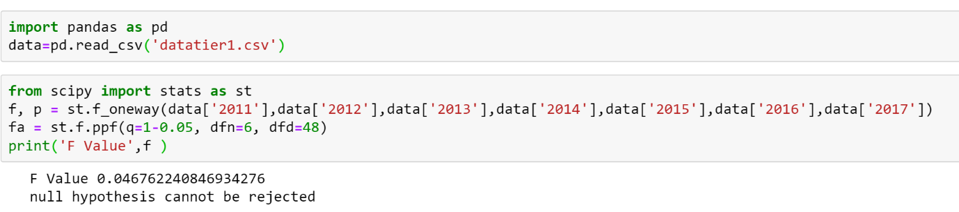

0.046>2.131;Null Hypothesis cannot be rejected, which signifies that the PM10 concentration have changed tier 1 cities in India from 2011 to 2017.



After calculation, we got correlation coefficient as 0.83, i.e. Population and ‘PM 10’ concentration is 83.0 % correlated.

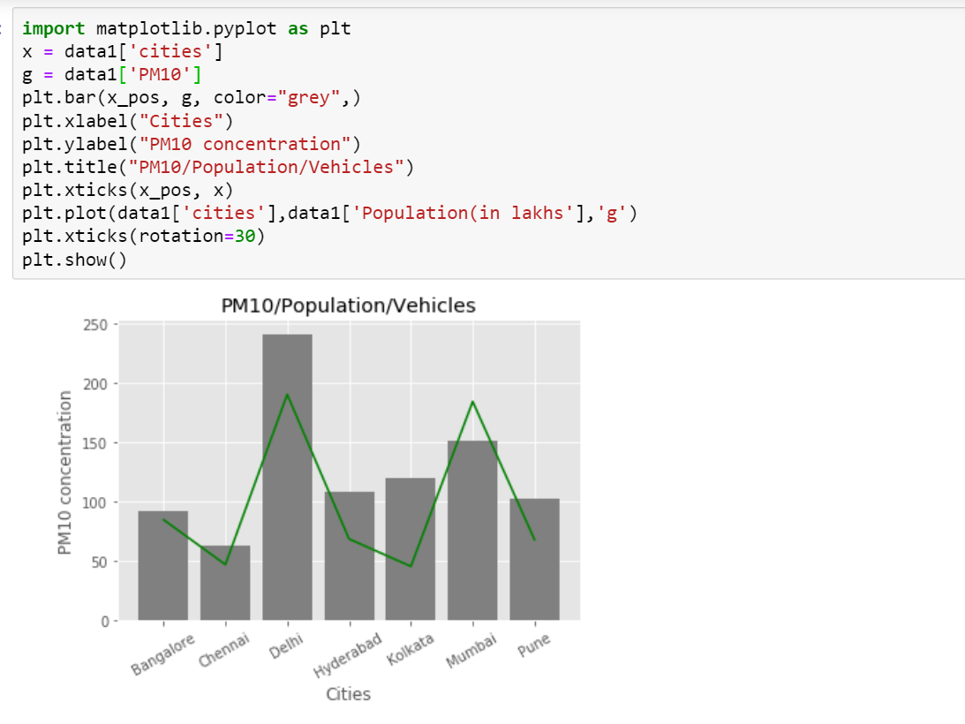

From the above graph we can conclude that the ‘PM 10’ concentration increases with the increase in population in tier 1 cities. Also, the correlation coefficient between population and pm 10 concentration came out to be 0.83 ..i.e. 83.0%.

**2. Python implementation for tier 2 cities:**

* Python code for ANOVA method

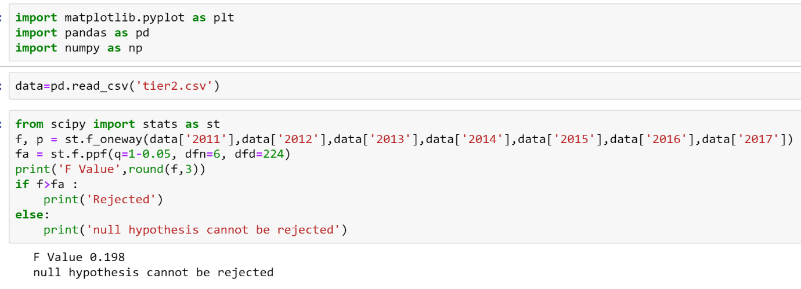

0.197>2.13;Null Hypothesis cannot be rejected, which signifies that the PM10 concentration have not changed in tier 2 cities in India from 2011 to 2017.

* Correlation code

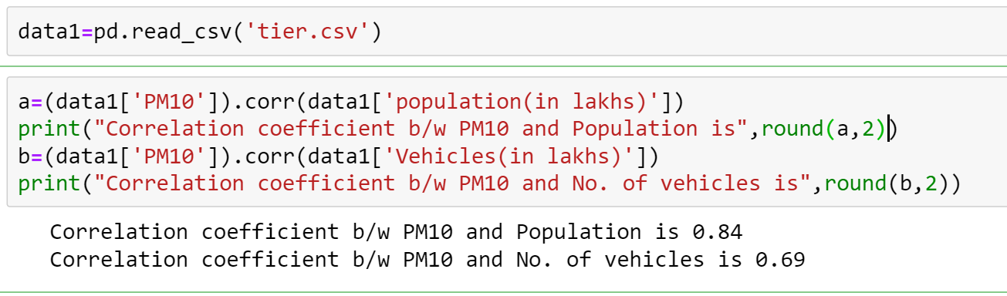

From the above result we can see that correlation coefficient b/w PM10 and population is 0.84 which tells us that as the population increases PM10 concentration increases.

Also , the correlation coefficient b/w PM10 and no. of vehicles is 0.69 which tells us that as the no. of vehicles increases PM10 concentration increases.

And both population and vehicles are correlated with each other so we are harming ourselves and creating environment loss

* Code for plotting Graph

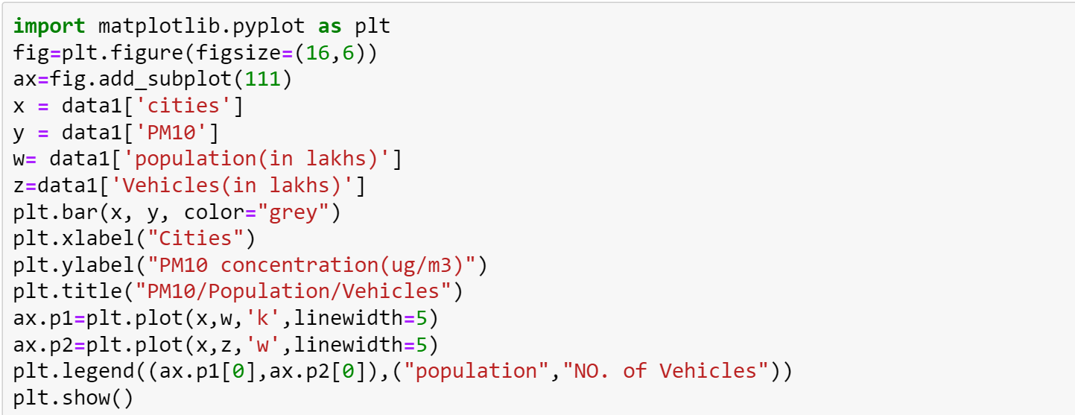

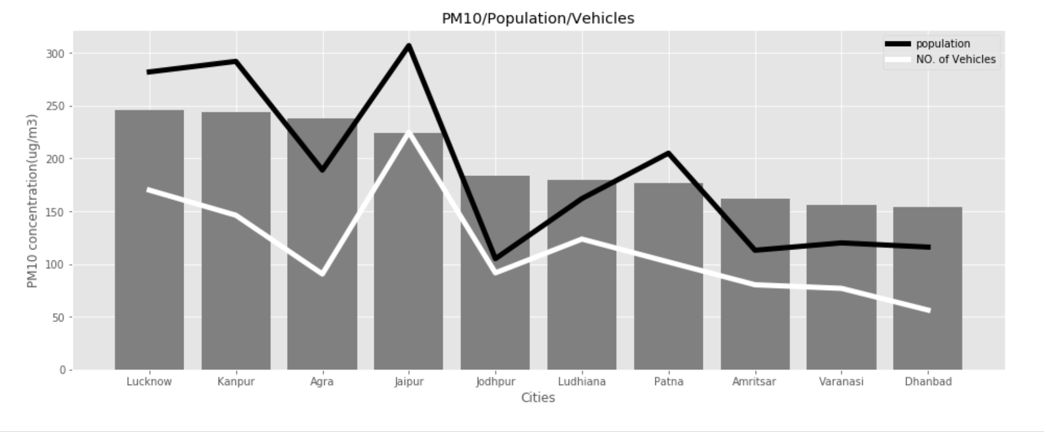

The above graph verifies the result of correlation. As we can see in the graph as the population and no. of vehicles increasing the PM10 concentration is increasing.

**3. Python implementation for tier 3 cities:**

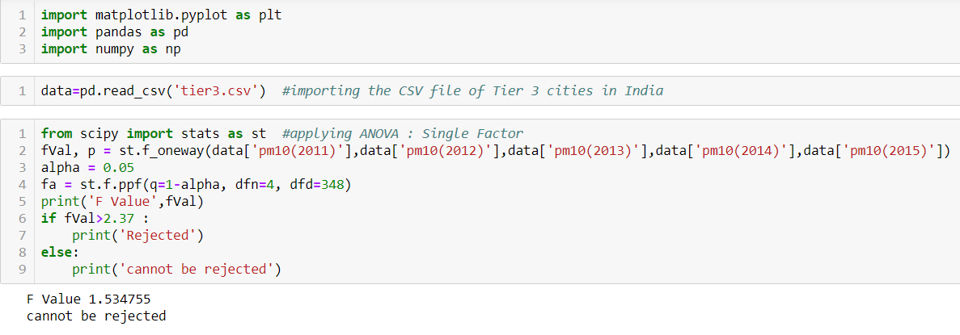

1.53>2.39; Null Hypothesis cannot be rejected, which signifies that the PM10 concentration have not increased in tier 3 cities in India from 2011 to 2015.

We then tried to find out a relation between population of cities and ‘PM 10’ concentration.

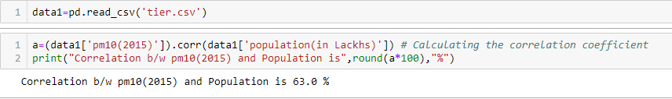

After calculation, we got correlation coefficient as 0.63, i.e. Population and ‘PM 10’ concentration is 63.0 % correlated.

Then we tried to verify our correlation by plotting a graph between Population and ‘PM 10’ concentration.

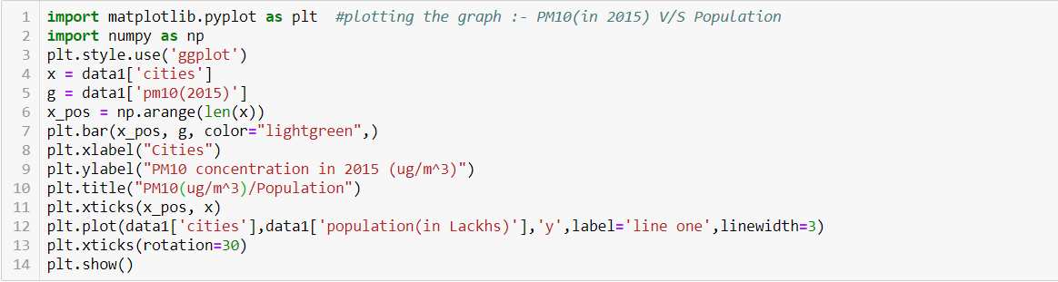

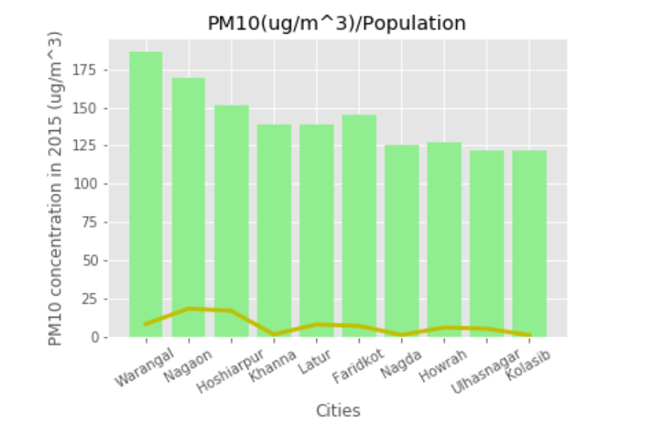

From the above graph we can conclude that the ‘PM 10’ concentration increases with the increase in population in tier 3 cities. Also, the correlation coefficient between population and pm 10 concentration came out to be 0.63 ..i.e. 63.0%.

**4. Python implementation for rural ares:**

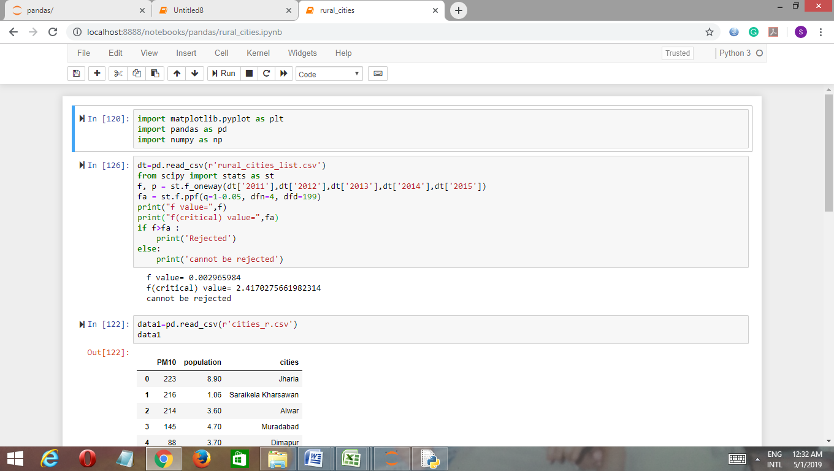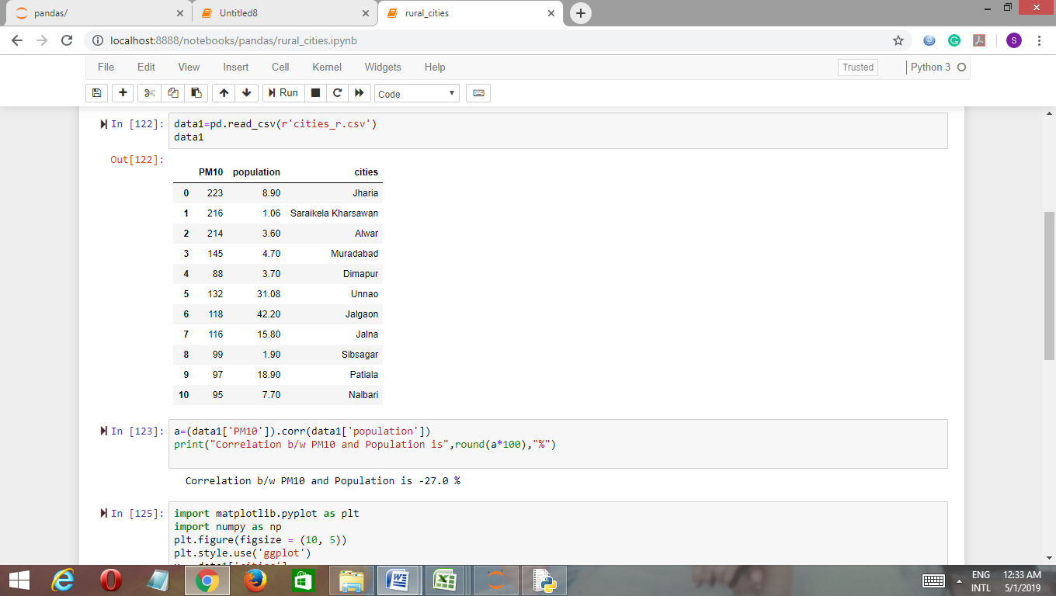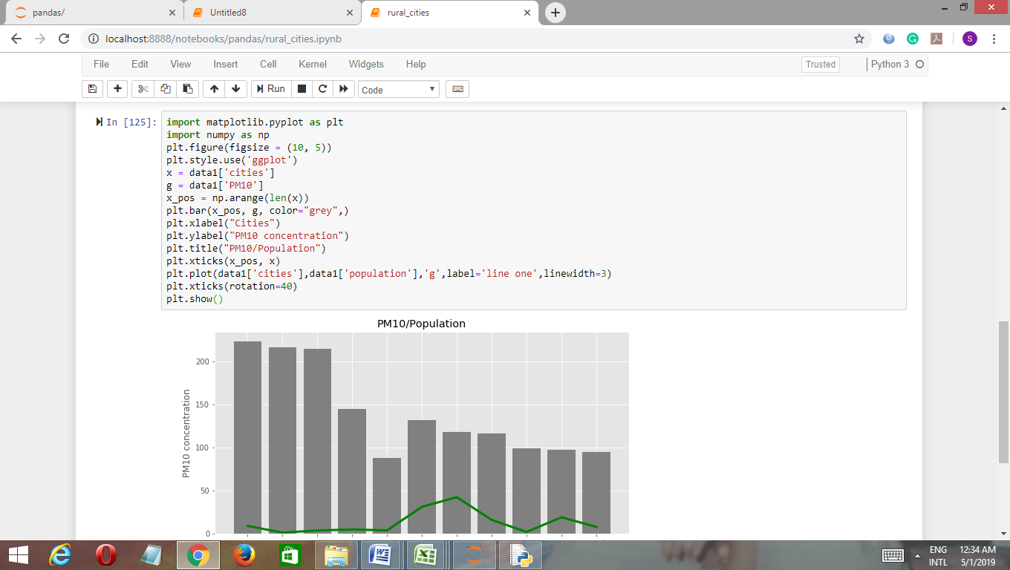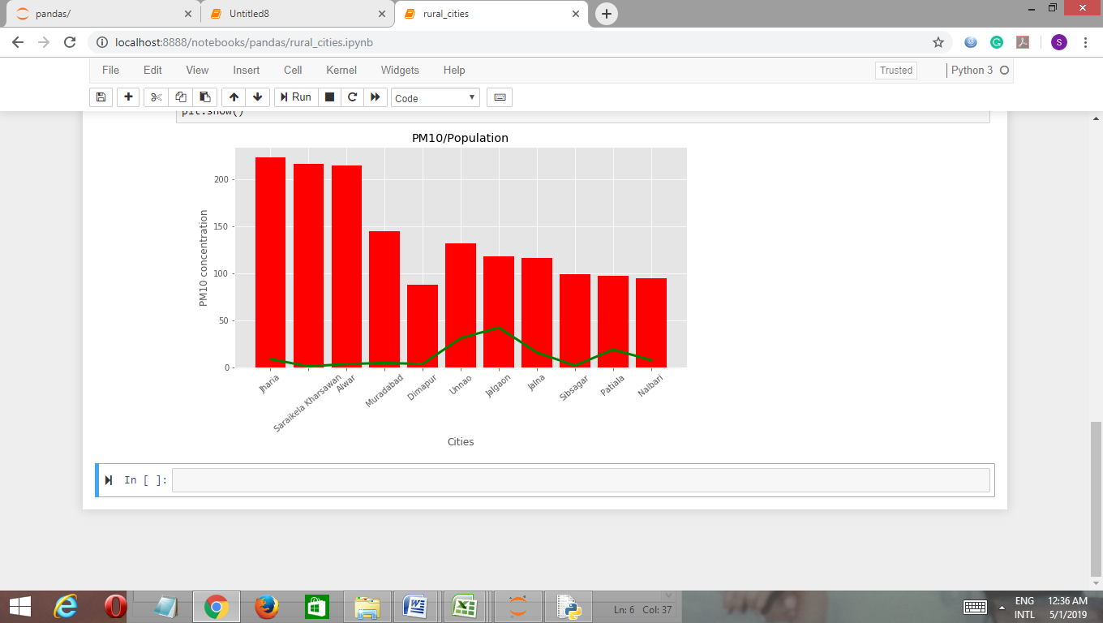

From the above graph we can conclude that the ‘pm 10’ concentration moderatly increases with the increase in population in rural area.

**4. Rank of all tier cities on the basis of pollution related to Pm10 concentration.:**

**Step 1:** All tier cities data was collected and written together in the excel sheet. The data is given below:

|  |  |  |  |  |  |  |  |
| --- | --- | --- | --- | --- | --- | --- | --- |
|  | cities | 2011 | 2012 | 2013 | 2014 | 2015 |  |
| City Number | pm10 | pm10 | pm10 | pm10 | pm10 | sum |
| 1 | Lakhimpur | 64 | 45 | 121 | 66 | 78 | 374 |
| 2 | Nellore | 63 | 62 | 76 | 77 | 82 | 360 |
| 3 | Kurnool | 82 | 74 | 59 | 56 | 62 | 333 |
| 4 | Muradabad | 145 | 165 | 160 | 201 | 168 | 839 |
| 5 | Chitoor | 39 | 40 | 70 | 76 | 88 | 313 |
| 6 | daranga | 56 | 56 | 98 | 70 | 69 | 349 |
| 7 | Dibrugarh | 42 | 56 | 99 | 44 | 109 | 350 |
| 8 | Golaghat | 63 | 55 | 101 | 63 | 124 | 406 |
| 9 | Nalbari | 95 | 82 | 140 | 76 | 120 | 513 |
| 10 | Sibsagar | 99 | 109 | 120 | 90 | 70 | 488 |
| 11 | Amona | 79 | 90 | 54 | 52 | 52 | 327 |
| 12 | Assanora | 78 | 84 | 57 | 50 | 54 | 323 |
| 13 | Codli | 76 | 121 | 0 | 60 | 56 | 313 |
| 14 | Jharia | 223 | 212 | 177 | 197 | 220 | 1029 |
| 15 | Saraikela Kharsawan | 216 | 160 | 121 | 100 | 75 | 672 |
| 16 | Belgaum | 41 | 72 | 0 | 150 | 99 | 362 |
| 17 | Devanagere | 67 | 75 | 26 | 25 | 25 | 218 |
| 18 | Gulburga | 63 | 65 | 96 | 90 | 75 | 389 |
| 19 | Mysore | 48 | 56 | 51 | 42 | 36 | 233 |
| 20 | Kottayam | 48 | 56 | 37 | 43 | 44 | 228 |
| 21 | Pathanamthitta | 22 | 23 | 64 | 63 | 67 | 239 |
| 22 | Sagar | 77 | 120 | 0 | 0 | 90 | 287 |
| 23 | Jalgaon | 118 | 130 | 122 | 137 | 118 | 625 |
| 24 | Jalna | 116 | 109 | 118 | 100 | 97 | 540 |
| 25 | Kolhapur | 86 | 110 | 97 | 90 | 78 | 461 |
| 26 | Nanded | 39 | 53 | 85 | 72 | 78 | 327 |
| 27 | Raebareli | 133 | 163 | 177 | 160 | 157 | 790 |
| 28 | solapur | 78 | 83 | 110 | 109 | 117 | 497 |
| 29 | tura | 59 | 52 | 48 | 43 | 44 | 246 |
| 30 | Aizawl | 46 | 54 | 42 | 36 | 33 | 211 |
| 31 | Champhai | 65 | 62 | 46 | 48 | 42 | 263 |
| 32 | Dimapur | 88 | 90 | 106 | 116 | 102 | 502 |
| 33 | Kohima | 77 | 82 | 87 | 87 | 82 | 415 |
| 34 | Rayagada | 58 | 54 | 96 | 83 | 100 | 391 |
| 35 | Sambalpur | 52 | 53 | 110 | 124 | 135 | 474 |
| 36 | Unnao | 132 | 98 | 114 | 73 | 119 | 536 |
| 37 | Naya Nangal | 76 | 89 | 76 | 68 | 77 | 386 |
| 38 | Patiala | 97 | 62 | 0 | 88 | 100 | 347 |
| 39 | Alwar | 214 | 151 | 160 | 150 | 171 | 846 |
| 40 | Salem | 65 | 60 | 87 | 84 | 85 | 381 |
| 41 | Nalgonda | 75 | 79 | 56 | 62 | 0 | 272 |
| 42 | Agra | 155 | 196 | 184 | 178 | 186 | 899 |
| 43 | Ahmedabad | 83 | 83 | 79 | 84 | 89 | 418 |
| 44 | Allahabad | 258 | 317 | 235 | 250 | 250 | 1310 |
| 45 | Amritsar | 210 | 202 | 180 | 145 | 148 | 885 |
| 46 | Asansol | 145 | 80 | 84 | 85 | 83 | 477 |
| 47 | Bhopal | 170 | 173 | 220 | 160 | 158 | 881 |
| 48 | Coimbatore | 102 | 68 | 56 | 49 | 47 | 322 |
| 49 | Dhanbad | 207 | 178 | 151 | 166 | 168 | 870 |
| 50 | Faridabad | 174 | 184 | 196 | 199 | 105 | 858 |
| 51 | Indore | 132 | 143 | 156 | 143 | 97 | 671 |
| 52 | Jabalpur | 73 | 75 | 69 | 73 | 90 | 380 |
| 53 | Jaipur | 139 | 187 | 160 | 150 | 171 | 807 |
| 54 | Jodhpur | 168 | 189 | 176 | 190 | 152 | 875 |
| 55 | Kanpur | 183 | 215 | 201 | 199 | 201 | 999 |
| 56 | Kota | 139 | 156 | 122 | 127 | 134 | 678 |
| 57 | Lucknow | 189 | 211 | 192 | 174 | 169 | 935 |
| 58 | Ludhiana | 221 | 228 | 204 | 146 | 139 | 938 |
| 59 | Madurai | 44 | 48 | 41 | 46 | 64 | 243 |
| 60 | Meerut | 12 | 129 | 134 | 154 | 0 | 429 |
| 61 | Nagpur | 108 | 103 | 89 | 103 | 90 | 493 |
| 62 | Nashik | 96 | 95 | 85 | 72 | 78 | 426 |
| 63 | Patna | 158 | 166 | 0 | 0 | 0 | 324 |
| 64 | Pimpri Chinchwad | 92 | 89 | 86 | 93 | 102 | 462 |
| 65 | Pune | 113 | 93 | 88 | 92 | 99 | 485 |
| 66 | Raipur | 268 | 291 | 305 | 329 | 188 | 1381 |
| 67 | Rajkot | 98 | 99 | 87 | 82 | 83 | 449 |
| 68 | Ranchi | 170 | 202 | 177 | 197 | 220 | 966 |
| 69 | Surat | 106 | 97 | 88 | 89 | 89 | 469 |
| 70 | Thane | 72 | 92 | 110 | 114 | 117 | 505 |
| 71 | Vadodara | 92 | 102 | 89 | 87 | 87 | 457 |
| 72 | Varanasi | 127 | 138 | 145 | 139 | 145 | 694 |
| 73 | Vijayawada | 90 | 65 | 104 | 100 | 110 | 469 |
| 74 | Visakhapatnam | 80 | 97 | 67 | 64 | 61 | 369 |
| 75 | Tirupati | 37 | 37 | 76 | 69 | 73 | 292 |
| 76 | Vishakhapatnam | 80 | 65 | 104 | 100 | 110 | 459 |
| 77 | Guwahati | 93 | 92 | 147 | 88 | 97 | 517 |
| 78 | Margherita | 53 | 54 | 77 | 55 | 115 | 354 |
| 79 | Nagaon | 86 | 79 | 132 | 100 | 137 | 534 |
| 80 | Silchar | 78 | 91 | 135 | 80 | 72 | 456 |
| 81 | Tezpur | 60 | 11 | 120 | 71 | 90 | 352 |
| 82 | Tinsukia | 56 | 57 | 99 | 57 | 119 | 388 |
| 83 | Korba | 94 | 81 | 77 | 72 | 66 | 390 |
| 84 | Margao | 90 | 67 | 60 | 70 | 74 | 361 |
| 85 | Marmagao | 72 | 112 | 46 | 51 | 52 | 333 |
| 86 | Panaji | 87 | 67 | 50 | 54 | 51 | 309 |
| 87 | Delhi | 222 | 237 | 55 | 63 | 62 | 639 |
| 88 | Bicholim | 111 | 119 | 48 | 52 | 49 | 379 |
| 89 | Curchorem | 87 | 112 | 54 | 46 | 49 | 348 |
| 90 | Honda | 184 | 135 | 54 | 65 | 60 | 498 |
| 91 | Tilamol | 150 | 114 | 50 | 54 | 51 | 419 |
| 92 | Usgao | 125 | 121 | 49 | 52 | 50 | 397 |
| 93 | Vasco | 57 | 84 | 79 | 84 | 89 | 393 |
| 94 | Anklesvar | 91 | 99 | 90 | 85 | 84 | 449 |
| 95 | Damtal | 67 | 97 | 0 | 32 | 37 | 233 |
| 96 | Dharamshala | 0 | 0 | 142 | 138 | 118 | 398 |
| 97 | Kala Amb | 170 | 165 | 48 | 40 | 46 | 469 |
| 98 | Nalagarh | 89 | 89 | 117 | 128 | 117 | 540 |
| 99 | Paonta Sahib | 72 | 153 | 68 | 66 | 61 | 420 |
| 100 | Parwanoo | 87 | 79 | 47 | 48 | 55 | 316 |
| 101 | Shimla | 54 | 57 | 74 | 87 | 83 | 355 |
| 102 | Sunder Nagar | 85 | 94 | 93 | 77 | 80 | 429 |
| 103 | Saraikela | 216 | 160 | 121 | 100 | 75 | 672 |
| 104 | Sindri | 214 | 170 | 0 | 0 | 111 | 495 |
| 105 | west Singhbhum | 231 | 153 | 113 | 139 | 119 | 755 |
| 106 | Hubli-Dharwad | 73 | 77 | 47 | 67 | 75 | 339 |
| 107 | Mandya | 43 | 49 | 60 | 56 | 48 | 256 |
| 108 | Mangalore | 55 | 31 | 79 | 112 | 92 | 369 |
| 109 | Alappuzha | 41 | 50 | 36 | 35 | 46 | 208 |
| 110 | Palakkad | 23 | 37 | 54 | 51 | 55 | 220 |
| 111 | Pathanamthitta | 22 | 23 | 46 | 55 | 48 | 194 |
| 112 | Thiruvananthapuram | 58 | 55 | 42 | 36 | 37 | 228 |
| 113 | Wayanad | 28 | 33 | 102 | 93 | 90 | 346 |
| 114 | Ujjain | 98 | 80 | 0 | 0 | 64 | 242 |
| 115 | Nagda | 101 | 103 | 0 | 163 | 125 | 492 |
| 116 | Akola | 137 | 139 | 84 | 85 | 83 | 528 |
| 117 | Amravati | 100 | 100 | 0 | 0 | 0 | 200 |
| 118 | Badlapur | 105 | 124 | 129 | 129 | 103 | 590 |
| 119 | Chandrapur | 152 | 148 | 91 | 141 | 104 | 636 |
| 120 | Latur | 116 | 117 | 131 | 112 | 163 | 639 |
| 121 | Lote | 86 | 40 | 0 | 0 | 0 | 126 |
| 122 | Dewas | 84 | 92 | 156 | 143 | 97 | 572 |
| 123 | Thane | 56 | 72 | 0 | 0 | 0 | 128 |
| 124 | Ulhasnagar | 114 | 111 | 122 | 136 | 122 | 605 |
| 125 | Shillong | 72 | 65 | 0 | 0 | 0 | 137 |
| 126 | Byrnihat | 178 | 138 | 36 | 42 | 36 | 430 |
| 127 | Dawki | 63 | 44 | 24 | 28 | 26 | 185 |
| 128 | Kolasib | 94 | 57 | 101 | 129 | 122 | 503 |
| 129 | Lunglei | 41 | 41 | 85 | 91 | 93 | 351 |
| 130 | Angul | 106 | 106 | 75 | 72 | 54 | 413 |
| 131 | Balasore | 76 | 82 | 87 | 90 | 81 | 416 |
| 132 | Berhampur | 75 | 80 | 83 | 92 | 81 | 411 |
| 133 | Bhubneshwar | 121 | 81 | 0 | 112 | 0 | 314 |
| 134 | Cuttack | 70 | 68 | 83 | 94 | 100 | 415 |
| 135 | Rourkela | 104 | 98 | 51 | 55 | 77 | 385 |
| 136 | Talcher | 109 | 116 | 43 | 42 | 35 | 345 |
| 137 | Puducherry | 42 | 42 | 0 | 35 | 35 | 154 |
| 138 | Dera Bassi | 105 | 129 | 0 | 74 | 90 | 398 |
| 139 | Faridkot | 0 | 0 | 165 | 135 | 130 | 430 |
| 140 | Gobindgarh | 166 | 201 | 0 | 55 | 72 | 494 |
| 141 | Hoshiarpur | 0 | 0 | 164 | 144 | 151 | 459 |
| 142 | Patencheru | 76 | 108 | 84 | 55 | 67 | 390 |
| 143 | Prakasam | 0 | 0 | 118 | 96 | 70 | 284 |
| 144 | Ramagundam | 65 | 82 | 49 | 52 | 58 | 306 |
| 145 | Warangal | 61 | 49 | 184 | 178 | 186 | 658 |
| 146 | Barrackpore | 98 | 130 | 166 | 103 | 113 | 610 |
| 147 | Durgapur | 166 | 108 | 160 | 102 | 101 | 637 |
| 148 | Haldia | 136 | 238 | 146 | 136 | 87 | 743 |
| 149 | Howrah | 131 | 186 | 187 | 111 | 123 | 738 |
| 150 | Raniganj | 153 | 126 | 163 | 134 | 114 | 690 |
| 151 | Khanna | 237 | 213 | 204 | 146 | 139 | 939 |
| 152 | Tuticorin | 130 | 134 | 61 | 67 | 0 | 392 |
| 153 | Bangalore | 91 | 121 | 113 | 139 | 119 | 583 |
| 154 | Chennai | 92 | 57 | 75 | 57 | 59 | 340 |
| 155 | Delhi | 222 | 237 | 221 | 217 | 220 | 1117 |
| 156 | Hyderabad | 74 | 79 | 90 | 95 | 93 | 431 |
| 157 | Kolkata | 113 | 135 | 159 | 122 | 105 | 634 |
| 158 | Mumbai | 116 | 117 | 117 | 96 | 107 | 553 |
| 159 | Pune | 113 | 93 | 88 | 92 | 99 | 485 |
|  |  |  |  |  |  |  |  |

Plotting Graph of pm10 concentration of all the cities from year 2011 to 2015:

**Step 2**: Sum of all the pm10 numbers of all the cities was done from year 2011 to 2015 and written in the “Sum matrix” excel file. Further it was imported to python. Python helped in forming a 159*159 matrix using comparison of sum of all the cities with one another.

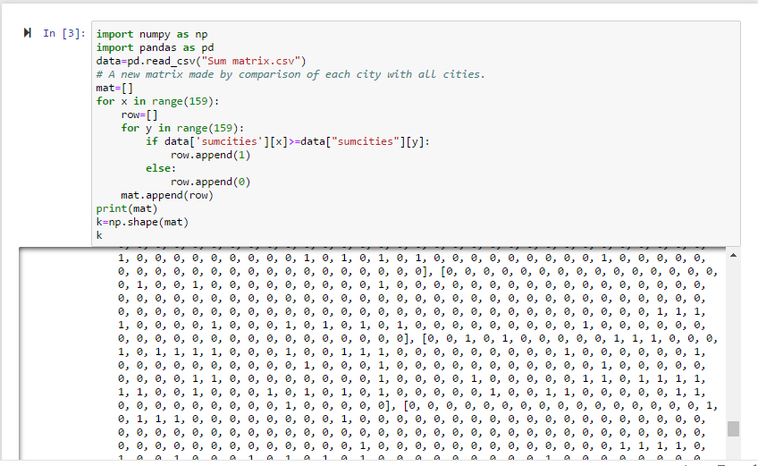

Step 3: Implementation in python of Power Method to find out the maximum Eigen value and Eigen vector.

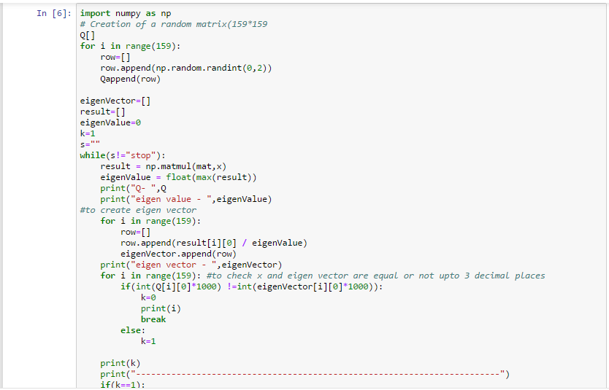

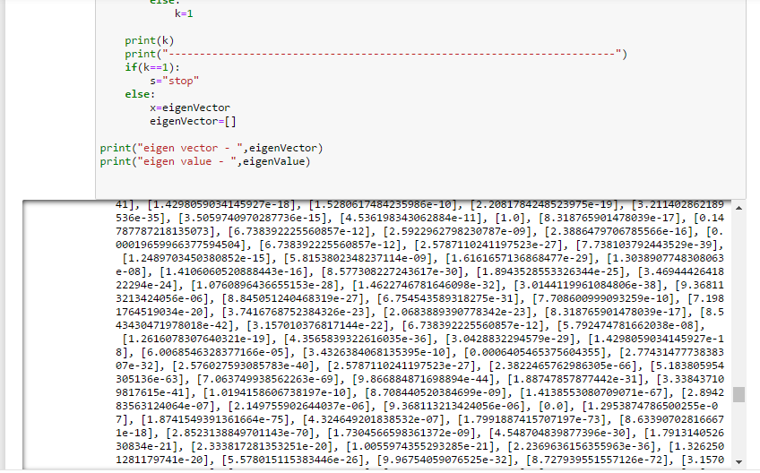

Step 4: Cities with their respective Eigen vectors were listed.

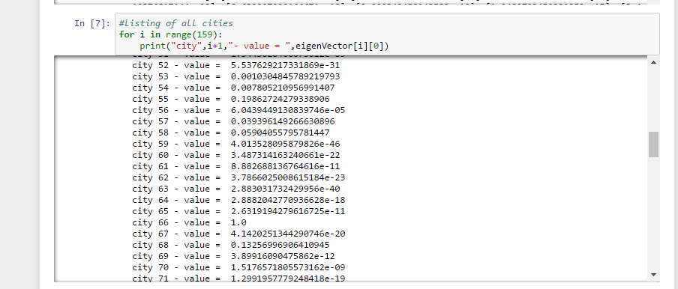

**Step 5:** According to the Eigen vector ranks were assigned to the cities. The ranks are given on the basis of the sum of pm 10 comparison between all cities with one another.

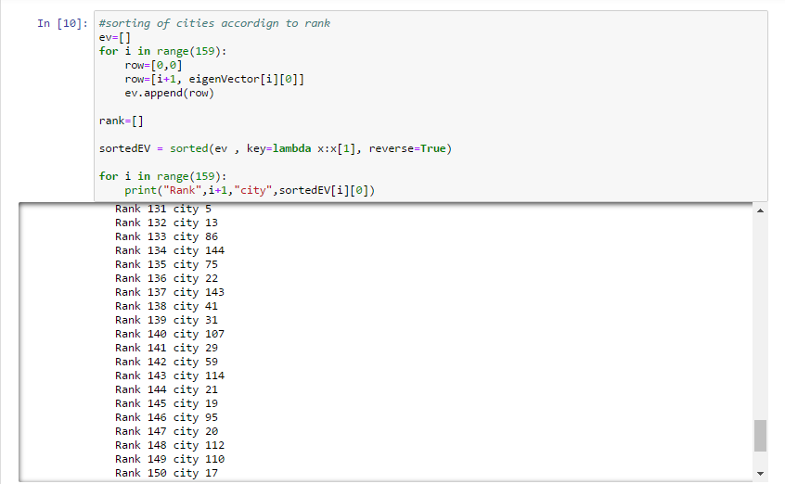

**The Rank of the cities are given by:**

Rank 1 - city 66 Rank 2 - city 44

Rank 3 -city 155

Rank 4 -city 14

Rank 5 -city 55

Rank 6 -city 68

Rank 7 -city 151

Rank 8 -city 58

Rank 9 -city 57

Rank 10 -city 42

Rank 11 -city 45

Rank 12 -city 47

Rank 13- city 54

Rank 14 -city 49

Rank 15 -city 50

Rank 16 -city 39

Rank 17 -city 4

Rank 18 -city 53

Rank 19 -city 27

Rank 20 -city 105

Rank 21 -city 148

Rank 22 -city 149

Rank 23 -city 72

Rank 24 -city 150

Rank 25 -city 56

Rank 26 -city 15

Rank 27 -city 103

Rank 28 -city 51

Rank 29 -city 145

Rank 30 -city 87

Rank 31 -city 120

Rank 32 -city 147

Rank 33 -city 119

Rank 34 -city 157

Rank 35 -city 23

Rank 36 -city 146

Rank 37 -city 124

Rank 38 -city 118

Rank 39 -city 153

Rank 40 -city 122

Rank 41 -city 158

Rank 42 -city 24

Rank 43 -city 98

Rank 44 -city 36

Rank 45 -city 79

Rank 46 -city 116

Rank 47 -city 77

Rank 48 -city 9

Rank 49 -city 70

Rank 50 -city 128

Rank 51- city 32

Rank 52- city 90

Rank 53 -city 28

Rank 54 -city 104

Rank 55 -city 140

Rank 56 -city 61

Rank 57 -city 115

Rank 58 -city 10

Rank 59 -city 65

Rank 60 -city 159

Rank 61 -city 46

Rank 62 -city 35

Rank 63 -city 69

Rank 64 -city 73

Rank 65 -city 97

Rank 66 -city 64

Rank 67 -city 25

Rank 68 -city 76

Rank 69 -city 141

Rank 70 -city 71

Rank 71 -city 80

Rank 72 -city 67

Rank 73 -city 94

Rank 74 -city 156

Rank 75 -city 126

Rank 76 -city 139

Rank 77 -city 60

Rank 78 -city 102

Rank 79 -city 62

Rank 80 -city 99

Rank 81 -city 91

Rank 82-city 43

Rank 83- city 131

Rank 84 -city 33

Rank 85 -city 134

Rank 86 -city 130

Rank 87 -city 132

Rank 88 -city 8

Rank 89 -city 96

Rank 90 -city 138

Rank 91 -city 92

Rank 92 -city 93

Rank 93 -city 152

Rank 94 -city 34

Rank 95 -city 83

Rank 96 -city 142

Rank 97 -city 18

Rank 98 -city 82

Rank 99 -city 37

Rank 100- city 135

Rank 101- city 40

Rank 102 -city 52

Rank 103 -city 88

Rank 104 -city 1

Rank 105 -city 74

Rank 106 -city 108

Rank 107 -city 16

Rank 108 -city 84

Rank 109 -city 2

Rank 110 -city 101

Rank 111 -city 78

Rank 112 -city 81

Rank 113 -city 129

Rank 114 -city 7

Rank 115 -city 6

Rank 116 -city 89

Rank 117 -city 38

Rank 118 -city 113

Rank 119 -city 136

Rank 120- city 154

Rank 121 -city 106

Rank 122 -city 3

Rank 123 -city 85

Rank 124 -city 11

Rank 125 -city 26

Rank 126 -city 63

Rank 127 -city 12

Rank 128 -city 48

Rank 129 -city 100

Rank 130 -city 133

Rank 131 -city 5

Rank 132 -city 13

Rank 133 -city 86

Rank 134 -city 144

Rank 135 -city 75

Rank 136 -city 22

Rank 137 -city 143

Rank 138 -city 41

Rank 139 -city 31

Rank 140 -city 107

Rank 141 -city 29

Rank 142 -city 59

Rank 143 -city 114

Rank 144 -city 21

Rank 145 -city 19

Rank 146 -city 95

Rank 147 -city 20

Rank 148 -city 112

Rank 149 -city 110

Rank 150 -city 17

Rank 151 -city 30

Rank 152 -city 109

Rank 153 -city 117

Rank 154 -city 111

Rank 155 -city 127

Rank 156 -city 137

Rank 157 -city 125

Rank 158 -city 123

Rank 159 -city 121

**The Result came out to be that the city 66 - “Raipur” is the most polluted and have very large PM10 concentration and the city which is least polluted is city 121-“Lote” which have very less Pm10 concentration.**

**Now the main question arises:**

**Raipur is not even in Tier 1 cities but is the most polluted city, why?**

-Several factors are responsible for the acute air pollution in Raipur:

1. Continuous increase in traffic

2. Rapid increase in industrialization

3. Black dust and soil dust

4. From constructional work

5. Cutting down trees.

**Conclusion:**

So from the above report we can conclude that as the population is increasing every year ,also the no. of vehicles are increasing which are directly affecting the air quality

Air quality plays a measure role in the phenomenon of climate change which is not only affecting India but all other countries and this is why SDG 13(Climate Action) is considered. Due to dirty air or low air quality many of our cities are affected ,also causing diseases, death to humans, damage to other living organisms such as animals and food crops, or the natural or built environment and affecting the “Life on Land” directly which is not good for humans.

So we can say humans are self-destroying the environment and making their life hard to live.

**Proposed solution:-**

This perhaps not the best way, but to eliminate air pollution sustainably require elimination/ minimize air pollution sources -

One way is plant a trees (a butt load of it) - grow an urban forest.

Trees and other plants make their own food from carbon dioxide (CO2) in the atmosphere, water, sunlight and a small amount of soil elements. In the process, they release oxygen (O2) for us to breathe.

**Trees**:

Help to settle out, trap and hold particle pollutants (dust, ash, pollen and smoke) that can damage human lungs.

Absorb CO2 and other dangerous gasses and, in turn, replenish the atmosphere with oxygen.

Produce enough oxygen on each acre for 18 people every day.

Absorb enough CO2 on each acre, over a year's time, to equal the amount you produce when you drive your car 26,000 miles. Trees remove gaseous pollutants by absorbing them through the pores in the leaf surface. Particulates are trapped and filtered by leaves, stems and twigs, and washed to the ground by rainfall.

Air pollutants injure trees by damaging their foliage and impairing the process of photosynthesis (food making). They also weaken trees making them more susceptible to other health problems such as insects and diseases.

The loss of trees in our urban areas not only intensifies the urban "heat-island" effect from loss of shade and evaporation, but we lose a principal absorber of carbon dioxide and trapper of other air pollutants as well.

Some of the major air pollutants and their primary sources are:

Carbon dioxide: Burning oil, coal, natural gas for energy. Decay and burning of tropical forests.

Sulfur dioxide: Burning coal to generate electricity.

Hydrogen floride and silicon tetrafloride: Aluminum and phospate fertilizer production, oil refineries, and steel manufacturing.

Ozone: Chemical reactions of sunlight on automobile exhaust gases. Ozone is a major pollutant in smog.

Methane: Burning fossil fuels, livestock waste, landfills and rice production.

Nitros oxides: Burning fossil fuels and automobile exhausts.

Chlorofluorocarbons: Air conditioners, refrigerators, industrial foam.

The burning of fossil fuels for energy and large scale forest fires such as in the tropics are major contributors to the build-up of CO2 in the atmosphere.

Managing and protecting forests and planting new trees reduces CO2 levels by storing carbon in their roots and trunk and releasing oxygen into the atmosphere.

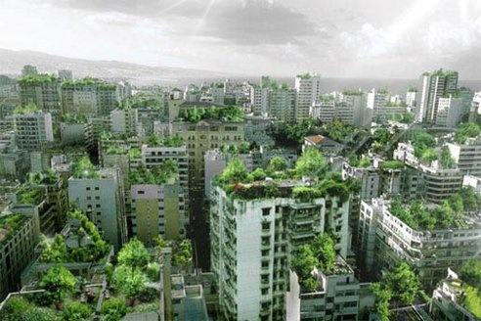

**References**

1. Airpocalypse: Assessment of Air Pollution in Indian Cities Written by Sunil Dahiya, Greenpeace Lauri Myllyvirta, Greenpeace Nandikesh Sivalingam, Greenpeace
2. <http://cpcbenvis.nic.in/air_pollution_control.html>
3. <https://www.undp.org/content/undp/en/home/sustainable-development-goals/goal-13-climate-action.html>
4. <https://www.undp.org/content/undp/en/home/sustainable-development-goals/goal-15-life-on-land.html>
5. The elemental concentrations of heavy metal pollutants that may be present in street dust samples in Mubi, Adamawa state, Nigeria, inferred by Shinggu, D.Y. Patel
6. A statistical approach of gaseous air pollutants based on traffic intersection and residential sites in Chennai city was investigated by Senthilnathan.T, (2008)
7. The spatial distribution of air pollution in response to recent air quality regulationsin Delhi, India monitored by Naresh Kumar and Andrew D.Foster (2009)
8. Concentration of air pollutants, meteorological parameters and traffic flow continuously measured by Gottinger Strasse (Hannover, Germany)
9. S. K. Puri and Gurdeep Singh 2004. Mitigation of Green House Gas EmissionsThrough Carbon Dioxide
10. <https://nptel.ac.in/courses/111107062/module3/lecture1/lecture1.pdf>